**Chapter 4**

**Differentiation of Functions of Several Variables**

**4.2 Limits and Continuity**

**Section Exercises**

**For the following exercises, find the limit of the function.**

1. 

Answer: 1

1. 

Answer: 2.0

1. Show that the limit  exists and is the same along the paths: -axis and -axis, and along *.*

Answer: The limits are all equal to zero along the three different paths.

**For the following exercises, evaluate the limits at the indicated values of . If the limit does not exist, state this and explain why the limit does not exist.**

1. 

Answer: 

1. 

Answer: 

1. 

Answer: 

1. 

Answer: 

1. 

Answer: 

1. 

Answer: 

1. 

Answer: 

1. 

Answer: 

1. 

Answer: 

1. 

Answer:

1. 

Answer:

1. 

Answer: 

1. 

Answer:

1. 

Answer:

1. 

Answer: The limit does not exist because when  and  both approach zero, the function approaches  which is undefined (approaches negative infinity).

**For the following exercises, complete the statement.**

1. A point in a plane region  is an interior point of if _________________.

Answer: there is a delta neighborhood about the point that lies entirely in 

1. A point  in a plane region  is called a boundary point of  if ___________.

Answer: every open disk centered at  contains points inside  and outside 

**For the following exercises, use algebraic techniques to evaluate the limit.**

1. 

Answer:

1. 

Answer:

1. 

Answer:

1. 

Answer:

**For the following exercises, evaluate the limits of the functions of three variables.**

1. 

Answer: 

1. 

Answer: The limit does not exist.

**For the following exercises, evaluate the limit of the function by determining the value the function approaches along the indicated paths. If the limit does not exist, explain why not.**

1. 
2. Along the -axis 
3. (b) Along the -axis 
4. (c) Along the path 

Answer: a. b.  c. 

1. Evaluate  using the results of previous problem.

Answer: The limit does not exist. The function approaches two different values along different paths.

1. 
2. Along the *x*-axis 
3. Along the *y*-axis 
4. Along the path 

Answer: a. b. c. 

1. Evaluate  using the results of previous problem.

Answer: The limit does not exist because the function approaches two different values along the paths.

**Discuss the continuity of the following functions. Find the largest region in the -plane in which the following functions are continuous.**

1. 

Answer: The function ** is continuous in the entire -plane.

1. 

Answer: The function  is continuous in the region .

1. 

Answer: The function  is continuous in the entire -plane.

1. 

Answer: The function  is continuous at all points in the -plane except at.

**For the following exercises, determine the region in which the function is continuous. Explain your answer.**

1. 

Answer: The function is discontinuous at  since is not in the domain.

1. 

(*Hint*: Show that the function approaches different values along two different paths.)

Answer: The function is continuous at  since the limit of the function at  is , the same value of .

1. 

Answer: The function is discontinuous at  since  is not in the domain.

1. Determine whether  is continuous at .

Answer: The function is discontinuous at . The limit at fails to exist and does not exist.

1. Create a plot using graphing software to determine where the limit does not exist. Determine the region of the coordinate plane in which  is continuous.

Answer: The function is continuous on every point of the *-*plane such that .

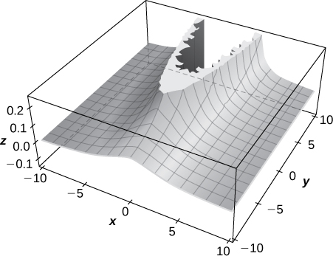

1. Determine the region of the -plane in which the composite function  is continuous. Use technology to support your conclusion.

Answer: Since the function  is continuous over , is continuous where  is continuous. The inner function  is continuous on all points of the -plane except where  Thus,  is continuous on all points of the coordinate plane *except* at points at which .

1. Determine the region of the -plane in which  is continuous. Use technology to support your conclusion. (*Hint*: Choose the range of values for  carefully!)

Answer: The function is continuous at all points in the -plane at which . These points are outside of the circle centered at the origin with radius .

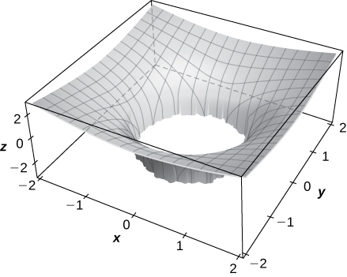

1. At what points in space is  continuous?

Answer: All points  in space

1. At what points in space is  continuous?

Answer: All points in space except where , a cylinder in which the intersection of the cylinder with the -plane is a circle of radius.

1. Show that  does not exist at  by plotting the graph of the function.

Answer: The graph increases without bound as  both approach zero.

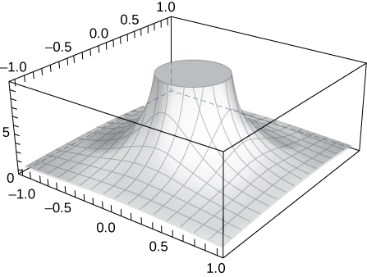

1. **[T]** Evaluate  by plotting the function using a CAS. Determine analytically the limit along the path .

Answer: The limit along the path  is 

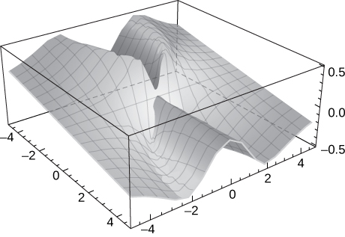

1. **[T]**
2. Use a CAS to draw a contour map of .
3. What is the name of the geometric shape of the level curves?
4. Give the general equation of the level curves.
5. What is the maximum value of ?
6. What is the domain of the function?
7. What is the range of the function?

Answer:

a.

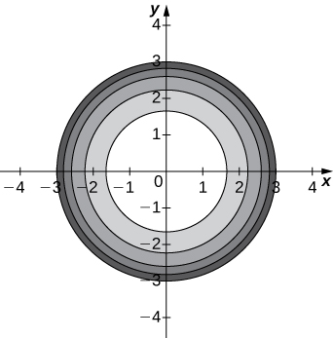

b. The level curves are circles centered at  with radius  c.  d.  e. f. 

1. *True or False*: If we evaluate  along several paths and each time the limit is , we can conclude that 

Answer: False. We would have to evaluate the limit of the function along every possible path, which is not possible. To prove that the limit is , we must use the epsilon–delta definition of the limit of a function of several variables.

1. Use polar coordinates to find . You can also find the limit using L’Hôpital’s rule.

Answer:

1. Use polar coordinates to find .

Answer: 

1. Discuss the continuity of  where  and 

Answer:  is continuous at all points  that are not on the line .

1. Given , find  .

Answer: 

1. Given , find  .

Answer:

This file is copyright 2016, Rice University. All Rights Reserved.